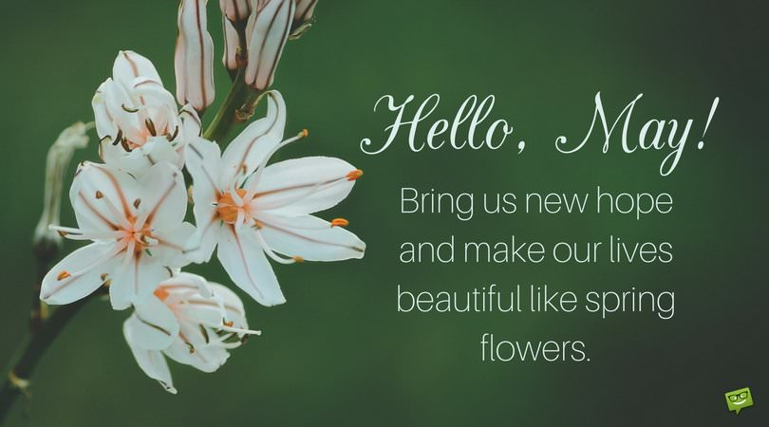
BWA Weekly Newsletter 1st May 2020
Can you believe it is May already?

Parents and Carers, you are doing a fabulous job supporting your children at home. Thank you for all you are doing to help the children with their home learning tasks and creating so many more opportunities for the children to experience during the lockdown. I attach a document we received this week in our inbox. I also came across the Royal Albert Hall home programme for kids and adults. If you have not discovered it already, it may be worth having a look. https://www.royalalberthall.com/tickets/series/children-and-families/

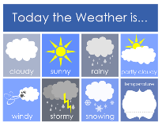
This weather this week has not been as good as the last few week. I am sure, like me, you have missed the glorious sunshine. Wet play is never a favourite for pupils or staff and I wonder how you all found it this week?

Our dedicated staff team have been working throughout the week on lessons for next week and safeguarding our pupils. They are in constant contact with our school community to make sure you have everything you need and to help out in any way we can. I am so grateful for their enthusiasm and commitment to every child.

Mental Health First Aiders
During this period of lockdown, many staff have signed up to do mental health training which is being offered through the trust. I am sure you will join me in offering sincere congratulations to the following staff who have been studying hard for this qualification.
Miss Ford
Miss Friday
Miss Jeffery
Miss Baker

Phone calls – every child, every week
This week teachers have continued with their weekly calls to every child. The staff have loved speaking to the children and you. Thank you for being so kind to them when they call, it is very much appreciated. With any new activity, there are aspects that are working well and some elements that could improve. I hear that some calls are taking quite a long time and that some of you are having calls from many staff which is taking up a lot of your time. Please be assured that we are reviewing all of this and will communicate any changes that we make to improve the experience.

This week SLT stared pupil progress meeting with the teachers and I can honestly say it has been one of my highlights of the week to hear all about the lovely calls they have had with you and to spend time with the teachers in a smaller group. During these meetings we have been reviewing the progress the pupils have made this year and what we can do during this lockdown to narrow the gaps in knowledge that we know exist. This information will help shape the next stage of our home learning strategy. We will be in contact with you if your child is being invited to attend a small group lesson with school staff. Please be assured we have been doing a lot of research on how children learn best remotely and what platforms we can use safely to protect the pupils and staff. I know so many of you are keen for this to start but you will understand that the safety of the pupils is paramount.

Seesaw
You are superstars …the work that we are seeing posted on Seesaw is wonderful. Well done everyone. Like I predicted in my video, you have made the teachers task of choosing the excellent learner of the week a very difficult one. Please keep up the great work. It is clear that you are using the excellent learner traits at home. To keep everyone safe make sure you don’t share passwords or logins with anyone. Any general questions can be sent to the admin email, which is checked throughout the day, Monday-Friday.

This week you will have watched my first head teacher video. In this video I set you a special task. Have you competed it yet? Please send these in by Monday 4th May. I am looking forward to learning what you think the best things about home learning are.

I hope you all stay safe and well and have a lovely, peaceful weekend. Please do remember to stay home to stop the spread of the virus.

Seana Henry
Headteacher

