Weekly Newsletter 12th June 2020
I hope you are all well, happy and had a super half term. Sadly there wasn’t much of a half term break for many BWA staff as we worked extraordinarily hard to continue to provide home learning for you all as well as prepare to open more widely for the year groups the government asked us to.

Will school open to all pupils before the summer holiday?
I have no doubt that many of you were very disappointed to hear that the government did not expect pupils in Years 2, 3, 4 and 5 to return to school before September. Please be assured that we will continue to provide excellent home learning provision for you all, respond to seesaw and our calls to you. We will also be reflecting on how we can continue to support you.

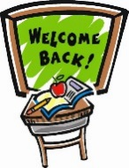
Wider opening of BWA this week
This week we welcomed two year groups back to BWA. Year 6 and Year 1. On Monday 15th June we will welcome pupils in our reception classes. For each class returning we have needed two classrooms (one for each hub of 15 pupils) and four adults as opposed to one classroom and 1 or 2 adults. In additional the bilingual classes returning will be taught by a BWA staff member 5 days a week rather than the agreed 2.5 days a week. These necessary changes have resulted in all of our available spaces, and staff, being allocated to the hubs onsite.
Teachers have been allocated to a hub but they will continue to call their own class and respond to Seesaw. At this stage, it is highly unlikely we will be able to open to year 2, 3, 4 & 5 in the future based on the information I have just shared with you. Please be assured that we will if we can.
What % of pupils returned to BWA this week?
The government believed that there would be a low demand for school places when they asked schools to consider opening to more pupils. Their survey reported that 19% of parents said they would return, 26% probably, 18% probably not, 15% no and 12% unsure. At BWA our indicative data was quite different to the national picture. Please see below.
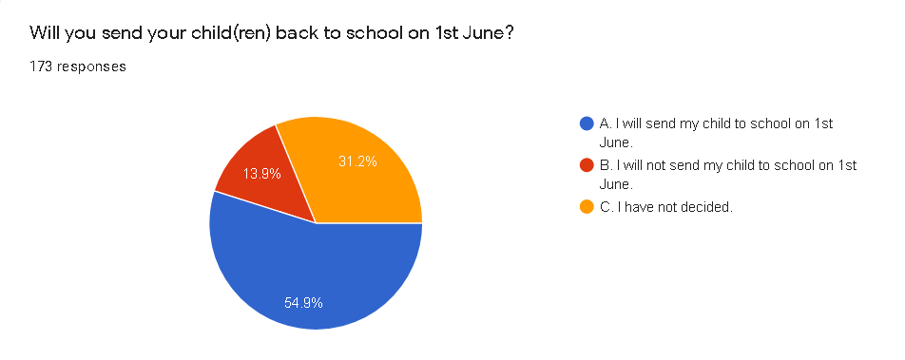

This table below shows the pupils that attended BWA this week
Year Group | % attending school this week
6 English Stream | 89%
6 Bilingual stream | 80%
Year 6 cohort | 84%
1 English Stream | 54%
1 Bilingual stream | 100%
Year 1 cohort | 65%
Reception – expected | 63%
What are the changes in school?
I attach a document that was shared with the families of pupils in the year groups returning to school, that you may find interesting.

Excellent Learners Update
We know that you enjoy receiving the weekly EL videos and hearing who has been awarded the Home Learning Superstar award in each class. This will continue for those year groups who are not in school. For year groups who have returned we will host a live, virtual assembly each week.

Sports Day & Art Gallery
You will have received information about this exciting art project and sporting event. We would encourage you to take part and look forward to seeing the BWA entries.

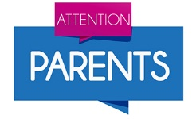
Contact details and health updates
Please can you inform us if you have changed your contact details and if there have been any changes about your child’s health that we should be aware of.

Seesaw
As you all know the Seesaw is working very well. Pupils enjoy sharing their home learning outcomes with their teacher. Our teachers love to see what the pupils have done at home and can tell it helps shape the support for each child. If you have any general queries, please do contact the school office to ensure you get a reply.
Thank you for your continued support. Small acts of kindness bring so much joy. We are all thinking of you at this time and look forward to seeing you soon. Have a wonderful weekend.
Miss Henry

Summary of the changes being made at BWA – Summer 2 2020
Social distancing | The government say they know that, unlike older children and adults, primary age children cannot be expected to remain 2 metres apart from each other, and staff. In deciding to bring more children back to schools, the government tell us they are taking this into account and are asking us to work through the hierarchy of measures set below:  - avoiding contact with anyone with symptoms  - frequent hand cleaning and good respiratory hygiene practices  - regular cleaning of settings  - minimising contact and mixing  It is still important to reduce contact between people as much as possible.  Pupils and staff should only mix in a small, consistent group and that small group should stay away from other people and groups, where possible.  Pupils will sit at desks and be spaced out as far apart as possible.  Dependent on the number of pupils returning, we cannot ensure that pupils will be sat at tables 2 metres away from each other.  We will have a staggered start and end of day. The times will be shared with you later this week.
COVID symptoms | Please do not enter the school site, or send your child to school, if either of you have symptoms of the virus.  We know that carriers of the virus may not show any signs of the virus and this is a concern that I am sure we all share.  Staff will have access to a thermometer to take pupils temperatures, as they feel is necessary.  Pupils who show signs of symptoms will be asked to go home and we ask that parents collect their child without delay, in this circumstance.
Staff Absence | Staff absence in a hub, may result in the pupils in the hub not being able to attend school.  We will endeavour to inform you as soon as this is the case. Please be aware that you may be informed on the morning that the hub is unable to attend school on the same day. I sincerely apologise for this as I know it is not ideal for you. Please be assured it is to keep your child as safe as possible.
Covid 19 test/ self-isolation | Pupils or teachers with symptoms will be able to get tested.  We will advise parents and carers in a hub affected by this, at the time.  Where a test result is positive, guidance states: “the rest of their class or group within their childcare or education setting should be sent home and advised to self-isolate for 14 days”.  “The other household members of that wider class or group do not need to self-isolate unless the child, young person or staff member they live with in that group subsequently develops symptoms.”  If other cases are detected, Public Health England’s local health protection teams will conduct a “rapid investigation” with the potential for the whole class or year group asked to self-isolate.
Hygiene | Please ensure that your child’s school clothes are washed after each day at school, in line with government guidance.  Throughout the day pupils will be asked to wash their hands with soap and water.  We will remind the children regularly about coughs and sneezes, using the phrase - Catch it, bin it, kill it.
Medication | Parent to inform the office of the need to complete a Medication Form. This will then be sent electronically, for completion.  Parents to email the school office to let them know it is there.  Office to contact the parent to agree when the medication will be dropped off.
Appointments | We ask that taking your child out of school for appointments is limited.  At the earliest convenience, parents are kindly asked to call the office to inform them of the need to collect the pupil. Share the preferred time and agree this with the staff.  On arrival at the gate, buzz to gain entry. Parent to wait by the blue gate.  Office to contact the hub the pupil is in for the child to be sent down.  Office staff will open the doors so the child can walk through and out to the parent.
Class size & teacher | Pupils will be split into hubs of no more than 15. They will not all be taught by their class teacher.  Class teachers will assign pupils to the hubs based on their knowledge of the pupils in their class. Twins will be allocated to the same hub.  Pupils in the hubs will not mix with other hubs – as explained above.  Where possible two adults (a teacher and TA) will be assigned to a hub.  Teaching assistants can be allocated to lead a group, working under the direction of a teacher, if there are shortages.
Classroom | Hubs have been assigned rooms across the BWA site. Many pupils will not be in their usual classroom.  The rooms have been stripped back to tables and chairs to ensure we can social distance as much as possible.  Pupils will not share resources outside of their hub.
Travel to school | We ask that you make every effort to:  - avoid public transport  - walk to school  - avoid bringing scooters or bikes onto the site, for reasons of contamination and storage space  If you do need to take a scooter or bike to school, the adult accompanying the pupil must take it to the car gate after dropping off the pupil. Indicate to Mr Jefford at the car gate that you need to access the storage area. As this area is used by Ecole de Wix, Jonathan will invite you to proceed through the car gate when it is safe to do so. Parents must socially distance and be mindful of the parents and pupils using this area for drop off.  Exit this area via the pedestrian gate.
Drop off and collection | We ask that only one adult accompanies the child (ren).  All BWA-registered children will enter and exit the site, at the times assigned to their hub, via the 1902 gate.  Parents are asked to queue on Wix’s Lane towards the Common, with 2m distances between each family group.  Residents of Wix’s Lane will be been informed of this arrangement, but we ask that you are of course mindful of allowing access to residents and pedestrians whilst you queue.
Lateness | We ask that you endeavour to ensure that you drop your child off and collect your child at the precise times to be given.  Start of Day  Arriving late increases the risk of the groups mixing, which we want to avoid.  Any child who arrives outside their allotted time, up to 9:30am, will need to wait opposite the 1902 gate with you, until staff are available to take them to their hub.  Late after 9:30  - Adults accompanying the child should call the office.  - Adult to come and wait by the blue gate until a staff member comes to collect the child.  - Office staff call the TA/ additional adult to collect pupil if they cannot make their own way to the classroom.  - When TA/additional adult arrives, office staff open office doors (as per delivery) and wait aside for pupil to walk through.  End of Day  Equally, at the end of the day, the impact of a child who is collected after the allotted time will be particularly compromising for the member of staff charged with their care.  Uncollected pupils  - Teacher/ adult to stay with children if social distancing possible.  - Take to 1902 gate at 2:25pm. Social distance by pirate ship – by fir trees.  - SLT to wait with pupils until collected.  - Office to call parents to establish ETA
After drop off | We kindle request that parents to not congregate outside the school.  If you wish to catch up with one another, please ensure that this happens with the appropriate social distance between you and away from the school site.  The window for children entering and exiting the site of necessarily large and their safe and calm coming and going must be our shared focus at these times.
Movement around the school site | There will be  - staggered entry, exit and break times  - pupils will eat their lunch in the hub classroom  - signs have been displayed to remind pupils to stay 2m apart when moving around the school  - pupils will be accompanied throughout the day by the adult(s) in their hub  Parents will not be allowed onsite unless invited by the headteacher.
Water fountains | Please provide your child with a bottle of water each day.  All water fountains have been disabled to avoid contamination.
School Dinners | A packed lunch option will be available. See Google form to order a packed lunch from school.  These will be delivered to the classroom and pupils will eat in their hub classroom.
Curriculum | It will not be practical to adopt the traditional approach to teaching that we are used to.  We will also continue with the home learning currently set up.
Bilingual Stream | Pupils in the bilingual stream will be taught in their registration groups.  It will not be possible to continue the traditional approach to teaching the classes in this stream, as explained in my joint letter with M. Bonnefoy to you last week. We are working with Ecole de Wix to find ways of ensuring some bilingual provision and exposure to your child’s French teacher each week, but both schools are firmly in agreement that the safety of the children and staff must come above the spirit and execution of our 2-way immersion provision at this time.
Shared Site | BWA is a unique school as we share a site and stream with the Lycee. In order to ensure we are all safe and able to ensure our own institution’s safety protocols at this time, precise areas of the building have been allocated for each school.  BWA  - Based on the ground and first floor  - Pupils and staff to access the building using the back stairwells and main reception area.  - Have dedicated areas for outside provision  - Pupils enter the site via the 1902 gate  Ecole de Wix  - Based on the second and third floors  - Pupils and staff to access the building using the main, front stairwell  - Have dedicated areas for outside provision  - Pupils enter the site via the car park gate  - Will not be onsite on a Wednesday
PPE | The guidance states that “the majority of staff in education settings will not require PPE beyond what they would normally need for their work, even if they are not always able to maintain a distance of 2 metres from others”.  The occasions where PPE is needed are for children whose care “routinely already involved the use of PPE due to intimate care needs” or if a youngster becomes unwell with coronavirus symptoms and needs “direct care until they can return home”.

