**Curriculum Evening Dates 2019-20**

Dear Parents and Carers,

We hope you had the most wonderful summer with your children. It has been a joy to welcome the children back to school and see so many of you after the break.

We would like to invite you to attend the Curriculum Meetings we have scheduled – please see the table below.

Knowing what to expect in the year ahead and having the opportunity to meet the class teachers should help us all work effectively together to ensure your child flourishes this school year.

All of the sessions are in the classroom and for adults only. Please enter the school building via the school office. Pupils will not be permitted to be in the room during the presentation.

|  |  |  |
| --- | --- | --- |
| **Date** | **Time** | **Bilingual Stream** |
| Monday 16th | 16:00 | Y6B / CM2B |
| 16:30 | Reception B / Moyenne Section B |
| Tuesday 17th | 16:30 | Y1B / GS B  Y2B / CP B  Y4B / CE2 B |
| Thursday 19th | 16:30 | Y3B / CE1 B |
| 17:00 | Y5B / CM1 B |

We do hope you can all attend one of the sessions and are looking forward to seeing you.

Kindest regards

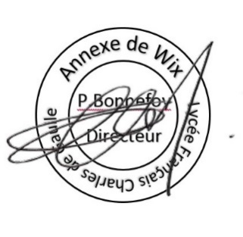

|  |  |
| --- | --- |
| Miss Séana Henry Headteacher  Belleville Wix Academy  cid:image001.jpg@01D49307.5325FE40 | Patrick Bonnefoy  Directeur  Ecole de Wix |