

**Reception Mother’s Day 2018-19**

**Early Bird Breakfast – Spring Term 2018/19**

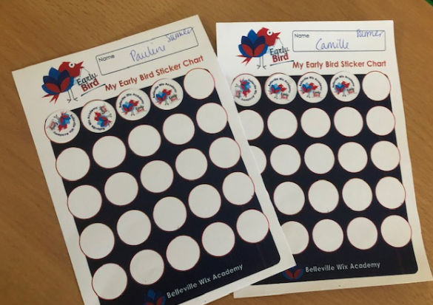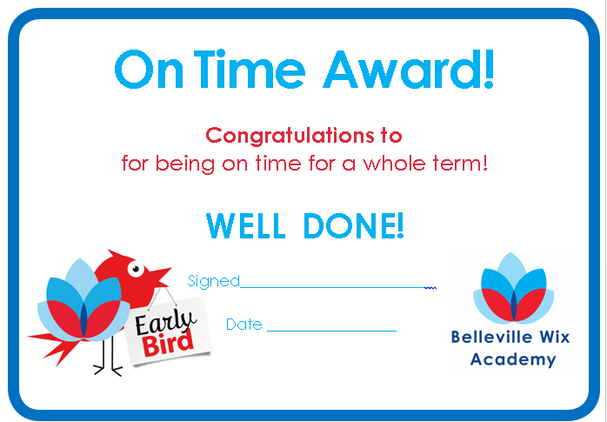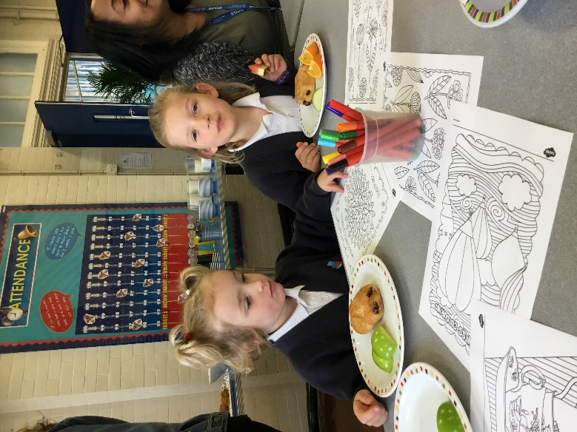

Everyone was presented with a certificate to celebrate their achievement.

At next term’s breakfast we are thinking of writing some top tips for getting to school on time!

We enjoyed a healthy breakfast and some mindfulness colouring for a calm start to our school day.

Our pupils with the best punctuality in each class were invited to join staff for a special Early Bird Breakfast at the end of term.