

**EYFS Father’s Day Celebrations**

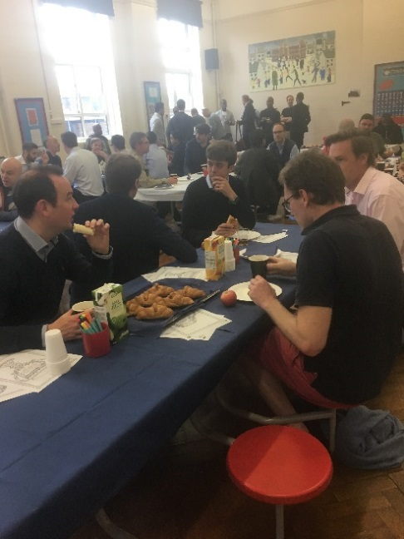Fathers and father figures are such important people in our lives that we wanted to say a special thank you to them.

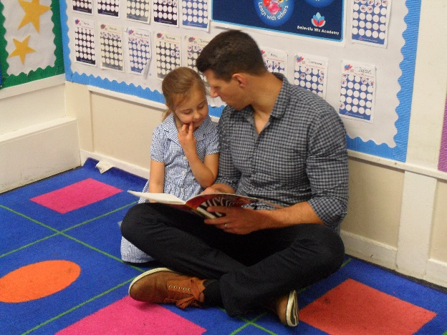

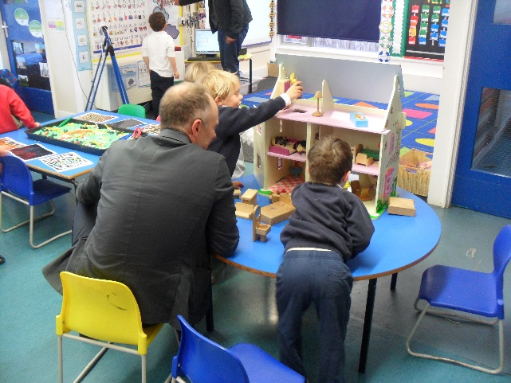

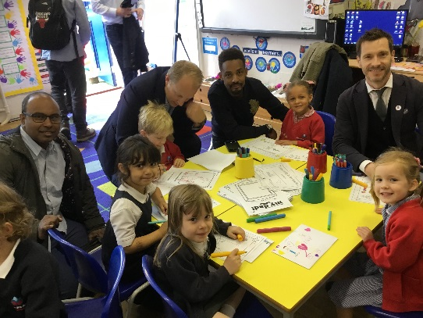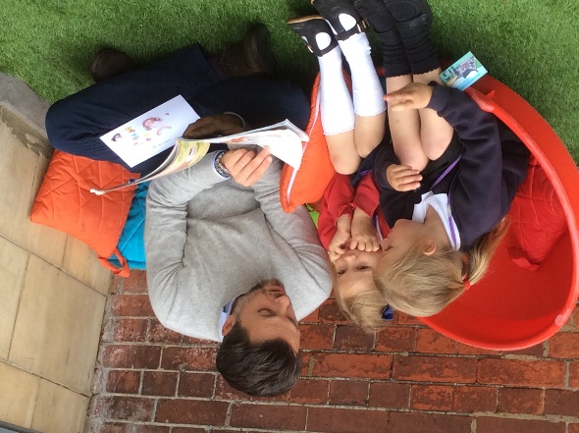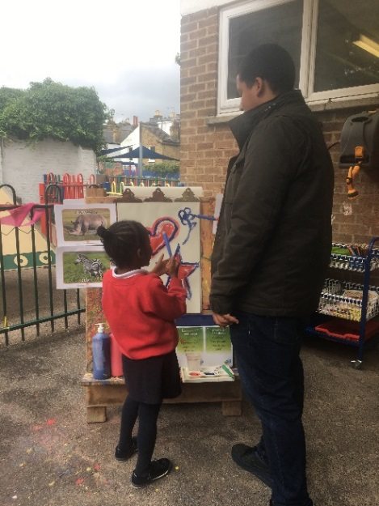

The children relished in the opportunity to have their fathers and father figures in school. They were able to share their favourite things about school and show them what we get up to!

We were so excited to have some daddies join us to play in nursery! The children were also keen to share their favourite books.