****

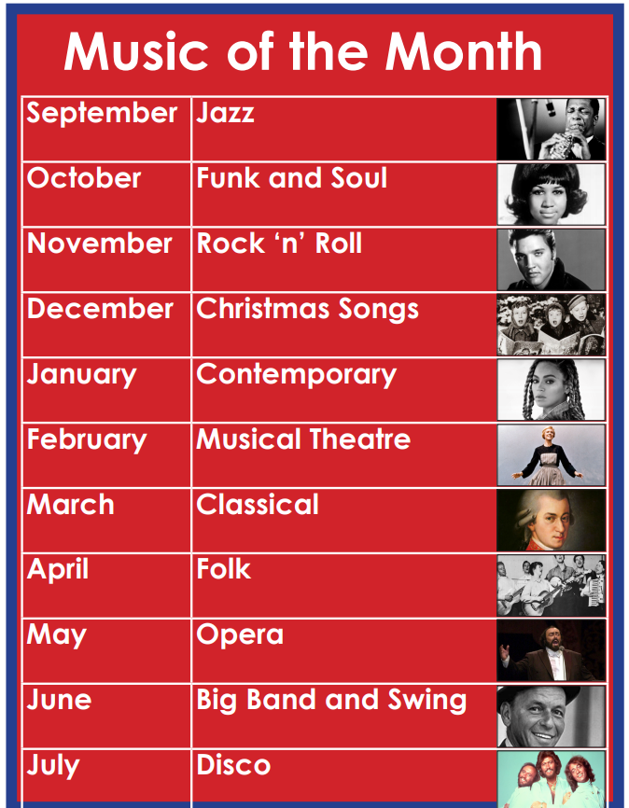

At Belleville Wix we enjoy getting to know different genres of music for each month. We have a display which is updated each month which teaches the children about the genre. The children also learn about the music in singing assemblies and learn a song from the chosen genre. We also enjoy listening to the music in soft start and as we come in to assemblies.

