

**Reception Mother’s Day 2018-19**

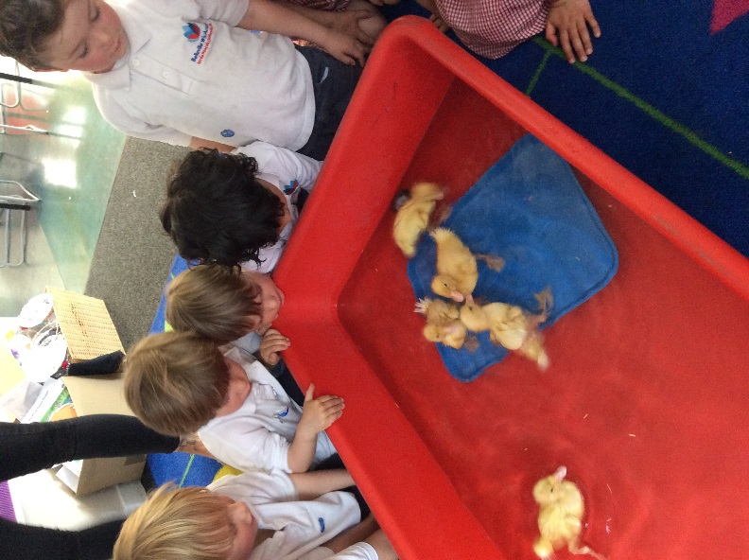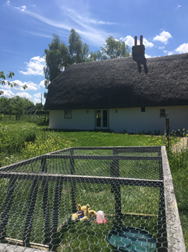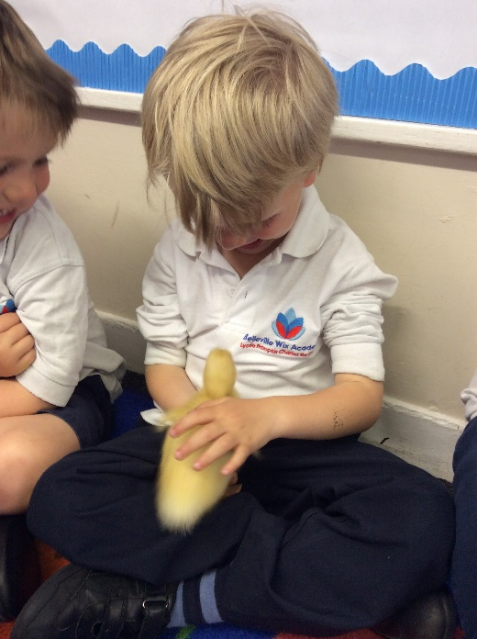**Nursery Ducklings: Summer 2019**

The children named the ducklings: Sonic, Anna, Elsa, Amy and Stanley! When the ducks were strong enough, we let them swim! We enjoyed watching them dive under the water.

Everyone had the opportunity to hold and stroke the ducklings. Eventually they grew too big to stay in their cage, and were very kindly taken in by a family who live in Essex, where they have lots of space to explore.

Nursery had a very special task- to hatch our very own duck eggs! We kept them warm inside an incubator until they were ready to hatch. After they had hatched, we put them into a large cage with food, water and a nice warm place to sleep.