

**Reception Mother’s Day 2018-19**

**Pancake Day 2018-19**

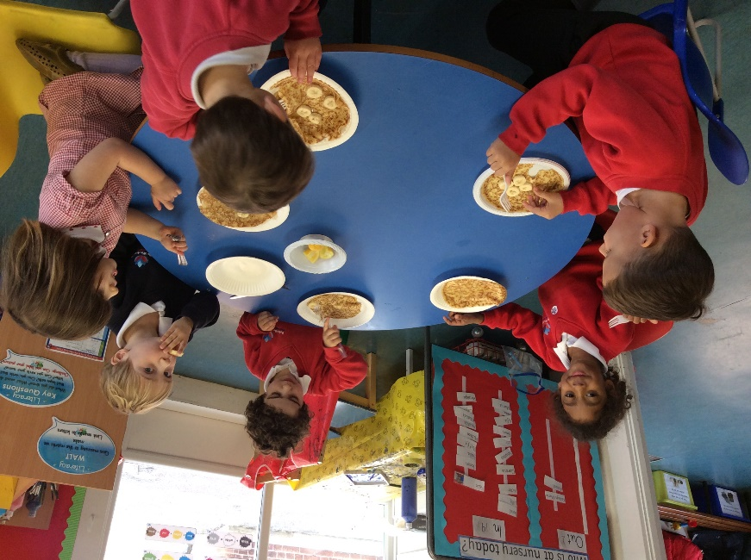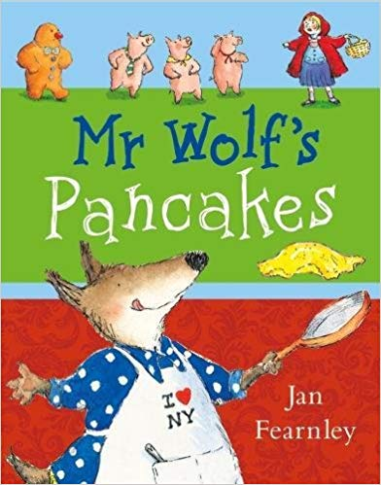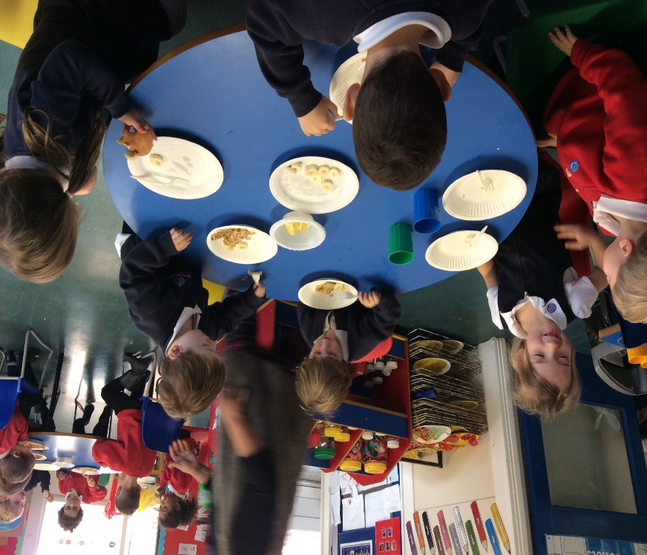

We adding toppings such as honey, lemon and banana to make our pancakes even yummier!

We read the story ‘Mr Wolf’s Pancakes’ to help us write a shopping list of the ingredients we would need to make our own pancakes.

In February, pupils in nursery learnt all about Shrove Tuesday and made delicious pancakes!