Lockdown Procedure

Jan 2019

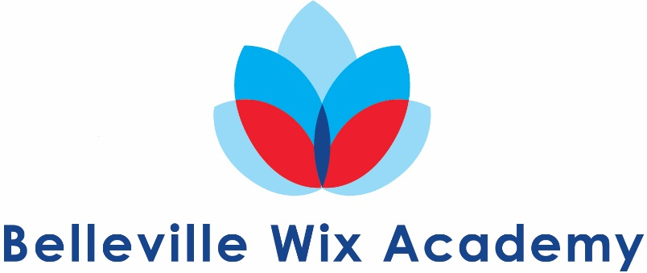
Parent Guidance for School on Lockdown

Should BWA ever need to Lockdown, parents are advised to adhere to the following guidance.
- If necessary, parents will be notified as soon as it is practical to do so via the school’s established communication network – website/group text/telephone.
- Depending on the type and severity of the incident, parents may be asked NOT to collect their children from school as it may put them and their child at risk.
- Pupils will not be released to parents during lockdown.
- Parents are requested not to call school as this may tie up emergency lines.
- If the end of the day needs to be extended due to the lockdown, the school will work hard to notify parents, via the school’s established communication network, of the revised arrangements about the time and place pupils can be picked up from.
- A letter to parents will be sent home at the nearest possible day following any serious incident to inform parents of context of lockdown and to encourage parents to reinforce with their children, the importance of following procedures in these very rare circumstances.

Please note that this is guidance only and every effort will be made to adhere to it however it must be understood that we cannot plan for every situation. Parents are asked to work with the school to ensure the safety of everyone should an emergency situation arise.

