

**Reception Thames Clipper Trip**

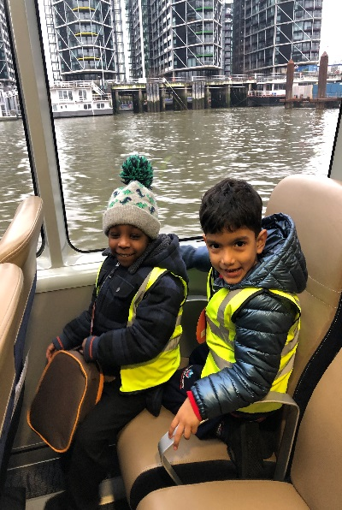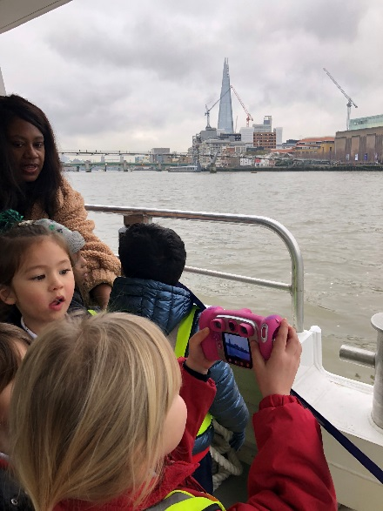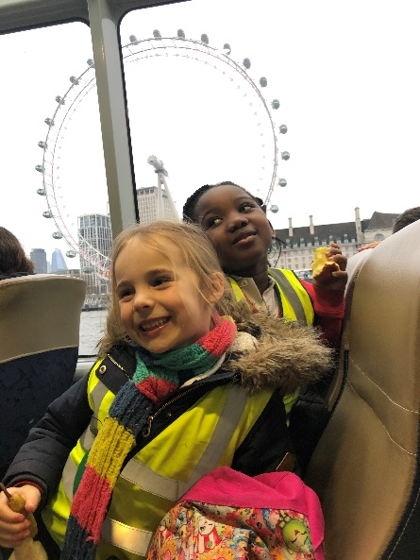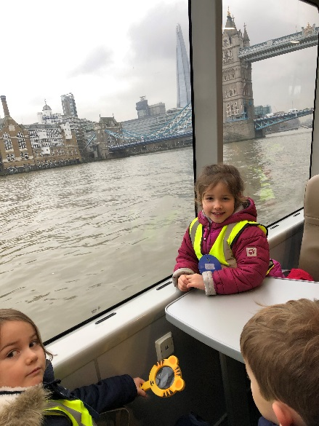

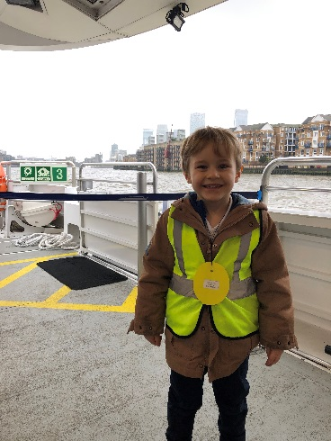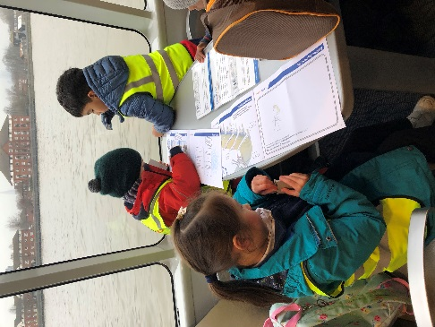

We loved going outside too, we got a much better view!

The children had activity booklets they went through with their grown up to check all the sites and bridges they had seen.

During our Journeys topic the children in Reception learnt all about London. So we embarked on our very own journey on the Thames Clipper to see some of the landmarks. We saw many different landmarks. The children were excited to see The Shard, The London Eye and Tower Bride. Unfortunately the bridge didn’t open up but we got to see where the Queen keep s all her jewels!