

**Reception Mother’s Day 2018-19**

**Chinese New Year in Reception 2018-19**

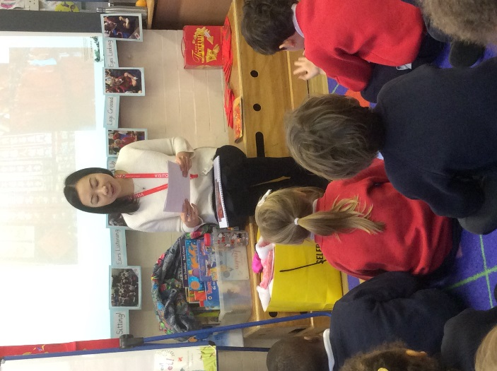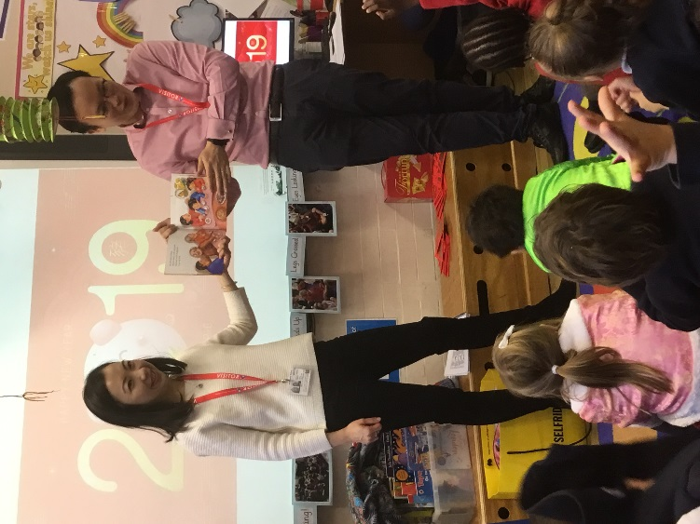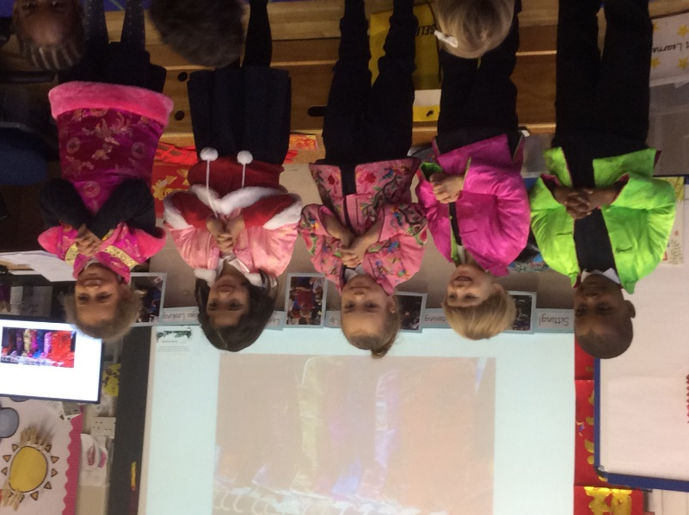

The children wore traditional clothes and decorated the class with lanterns they made in class. It was fully immersive day, spending the day doing a range of activities.

Parents from the school kindly came into Reception and helped us to learn more about Chinese New Year!

They did lots of things with us and we even learnt how to say Happy New Year in Chinese - ‘**Kung Hei Fat Choi’.**