

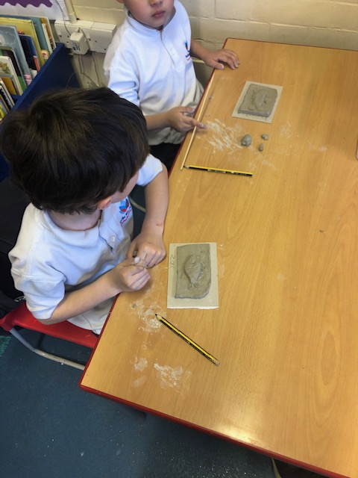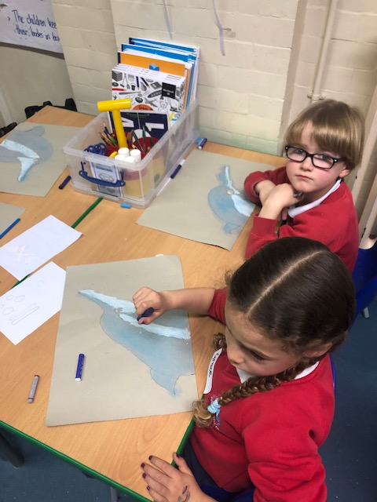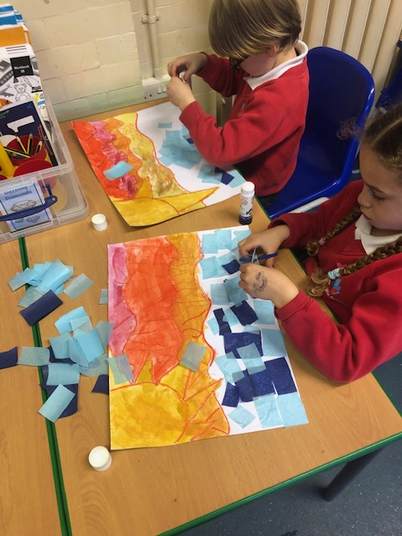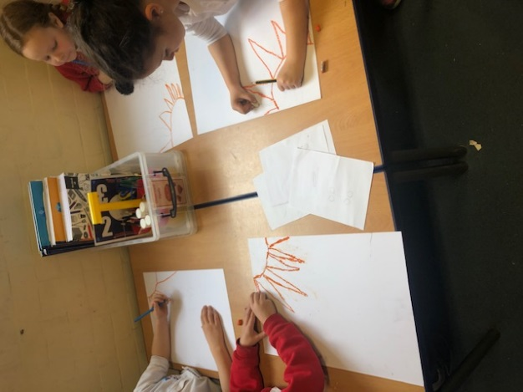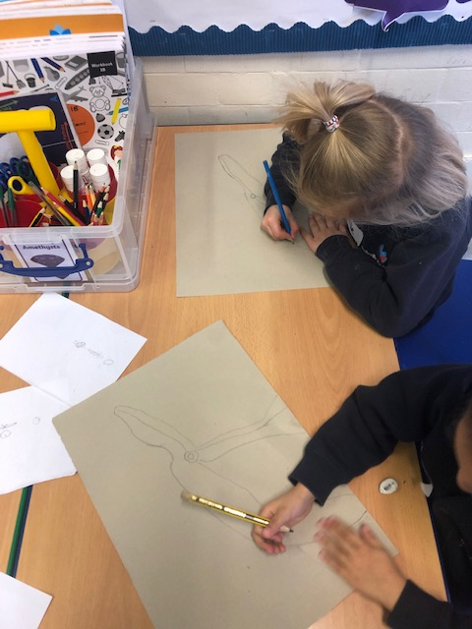**Year 1B Art 2018-19**

Year 1B explored two different mediums to create a collage picture and a clay model.

In the afternoon the children created fish out of clay. They explored hatching techniques to make pieces stick together and used new tools and techniques to add detail.

The children completed their pictures step by step. First, a line drawing which they coloured with oil pastels.

Their focus and attention to detail was amazing!