

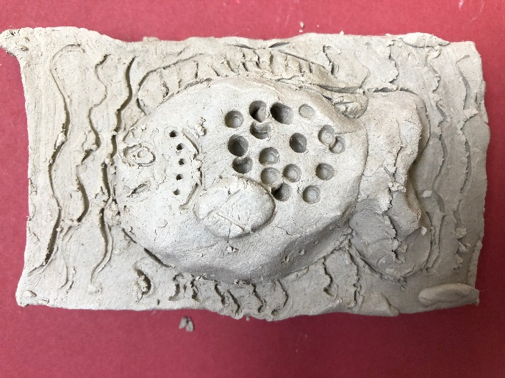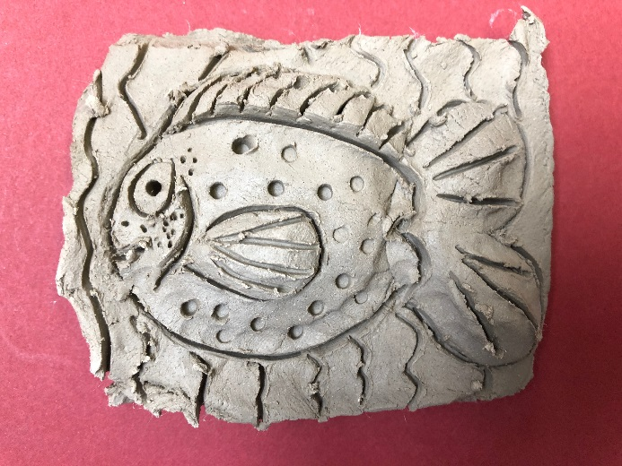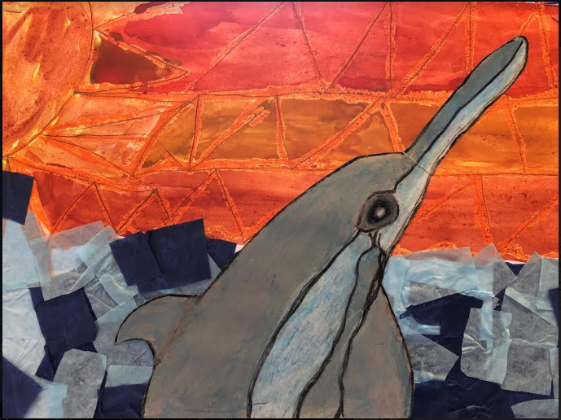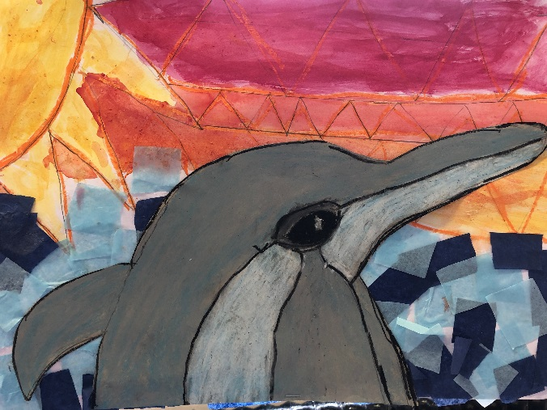**Year 2 Art 2018-19**

We used oil pastels and water colours to create these beautiful masterpieces which show a dolphin coming up, out of the water!

We also engraved these fish into clay. How amazing they are!

Year 2 had an amazing Art day at the beginning of Summer 1.