

**Year 3 ICT 2018-19**

Year 3 uploaded pictures to the i-movie app the make their own film using i-pads.

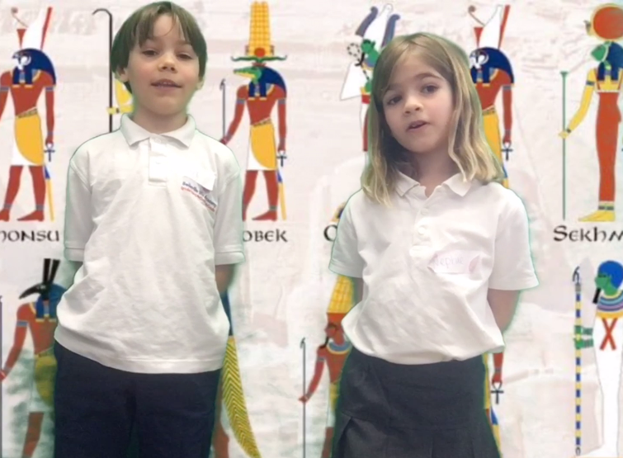

They then used a green screen to make their very own Egyptian documentaries!

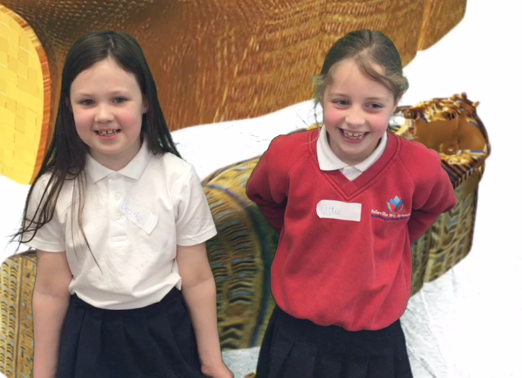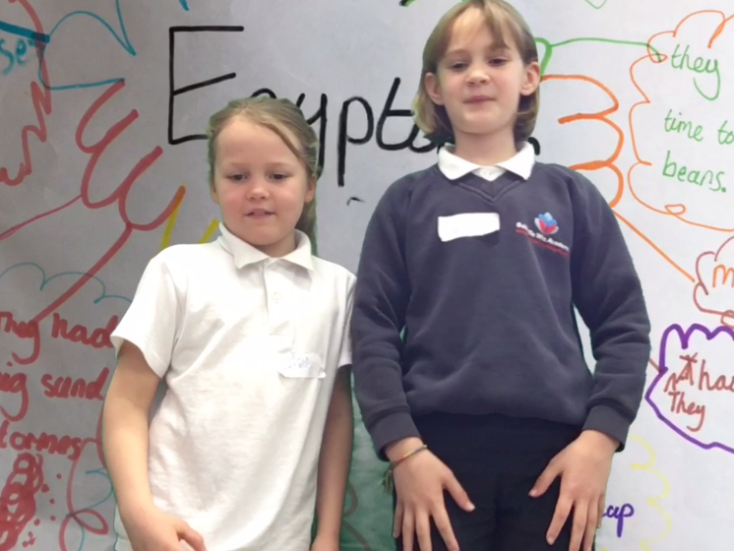

They spent the afternoon learning how to code using Hopscotch.