

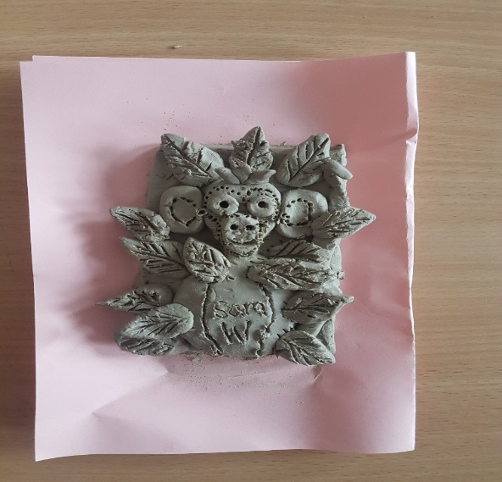**Year 4 Art 2018-19**

Year 4 have been creating works of art based on the artist Frida Kahlo.

These are our stunning portraits of Frida. We used a variety of materials and techniques to create them, including pencil, pastel, watercolour and tissue paper.

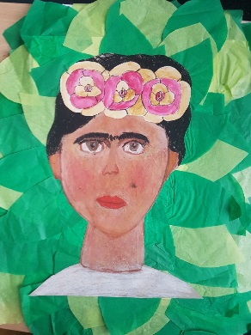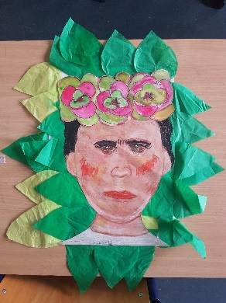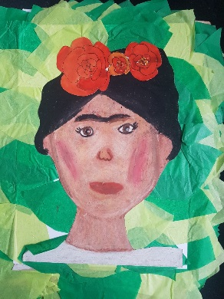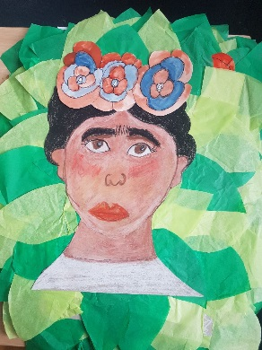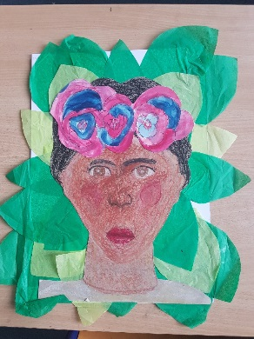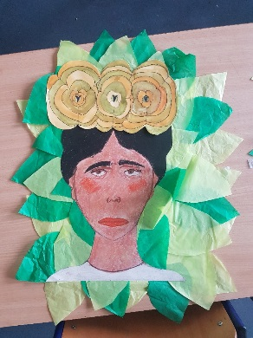

We have also created monkeys out of clay. First, we designed our 3D models in 2D and then we used our fingers and the tools to create the detailed monkeys and patterns on around the monkeys. The results were fantastic!