

**Year 4 ICT 2018-19**

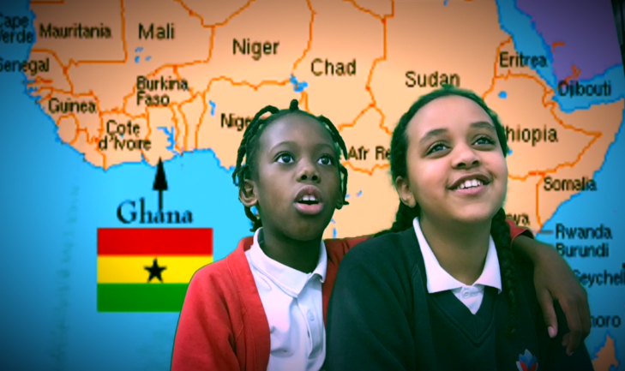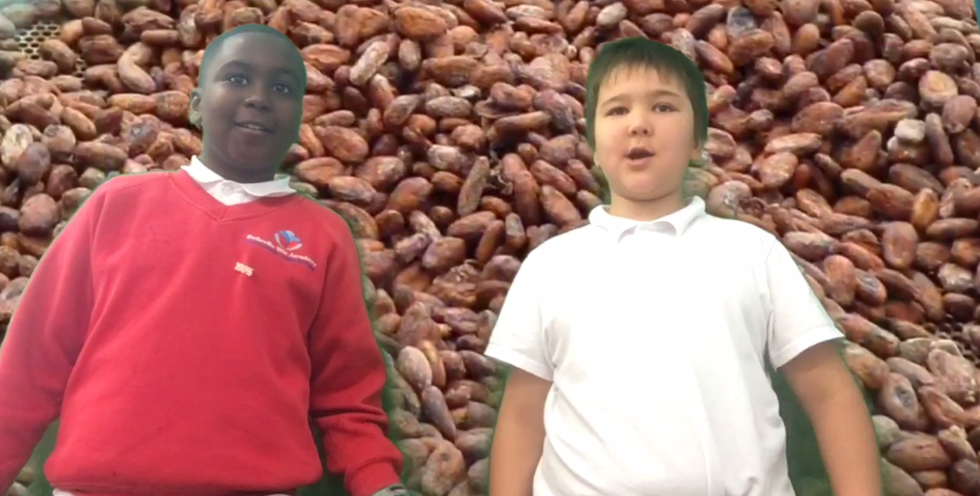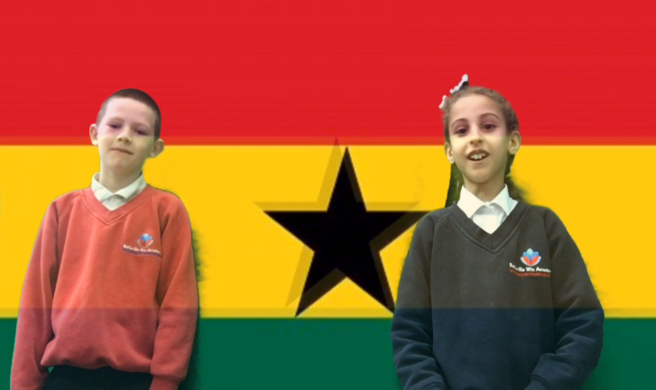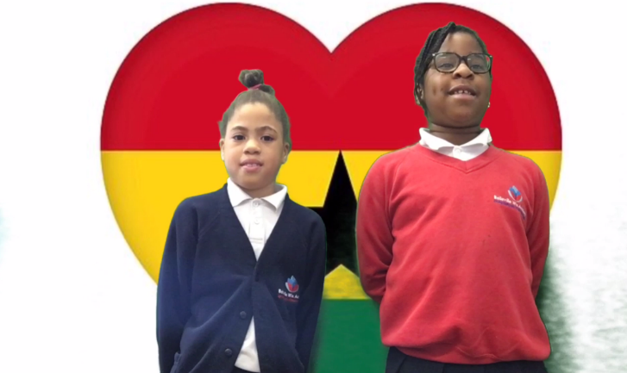

Lastly, the children had to add an introduction and an outro screen to their movie and add some music for the non-speaking screen. Once they had finalised their movie they saved it, ready to be exported. Well done Year 4

Once the children had finalised their movie and the script, they came up to the green screen and filmed their facts they had found out about Ghana. All of the children managed this in one take!!

Their first task was to find some photographs that they would want to use as their background for their movie. They put these photos into a movie making program and then wrote a script for what they would say.

Year 4 have been studying about Ghana in our topic lessons. We have been looking at chocolate production in Ghana and also what education is like in Ghana. The task, during our ICT day was to create a movie based on what we had been learning about in Topic.