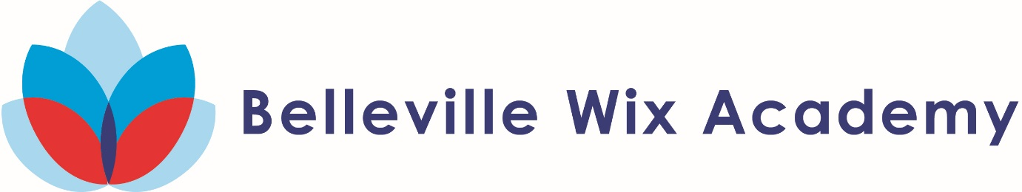

**Year 6 Art 2018-19**

During the art lessons in the spring term, Year 6 they learnt many new skills and produced these wonderful pieces of art.

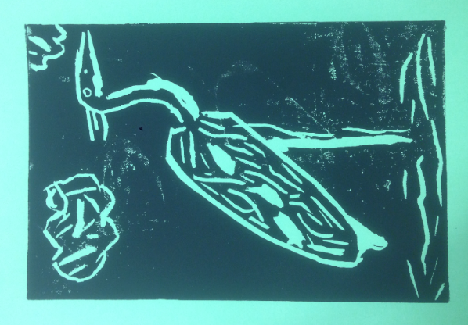

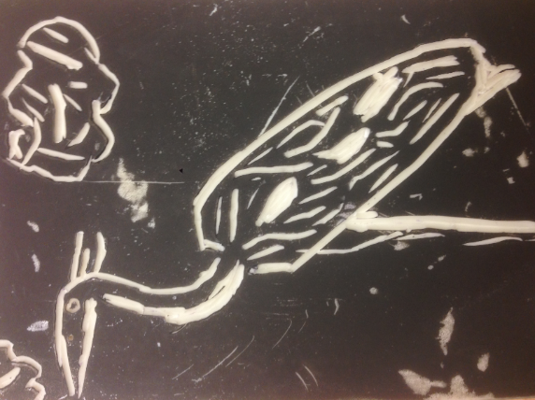

They drew herons in the river and printed them using carbon paper and lino printing tools.

Year 6 really enjoyed creating these beautiful pieces of work.

