Parent Gym comes to Belleville Wix Academy

Belleville Wix Academy are hosting Parent Gym for a 6 week parenting programme.
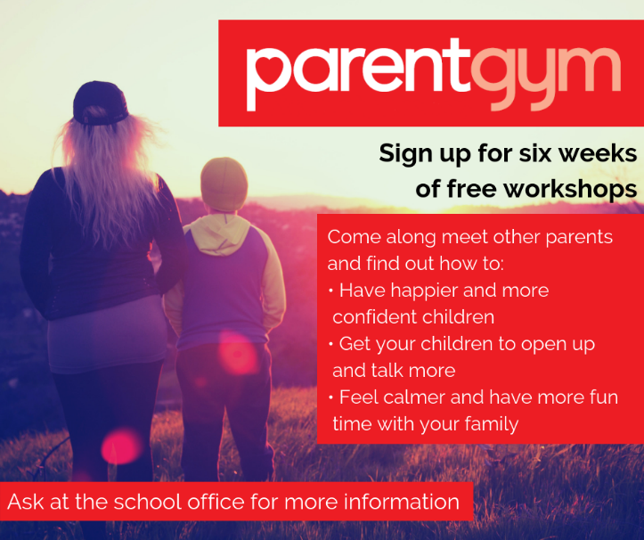
A successful taster session was run last week and we are exciting to start the programs first session on Thursday 17th October.
For more information about the program and how to join, please follow this link https://bit.ly/2khwycW .

